**SCHOOL OF COMPUTER SCIENCE AND ENGINEERING**

**CSE2007 – Database Management Systems**

**WIN SEM**

**CLASS NUMBER: 22BCE8068 SLOT: L45+L46**

LAB - 1

**Q1:** create following tables:

bonus:

Name Null? Type

ENAME VARCHAR2(10 CHAR) JOB VARCHAR2(9 CHAR)

SAL NUMBER

COMM NUMBER

emp:

Name Null? Type

EMPNO NOT NULL NUMBER(4) ENAME VARCHAR2(10 CHAR) JOB VARCHAR2(9 CHAR)

MGR NUMBER(4)

HIREDATE DATE

SAL NUMBER(7,2)

COMM NUMBER(7,2)

DEPTNO NUMBER(2)

dept:

Name Null? Type

DEPTNO NOT NULL NUMBER(2)

DNAME VARCHAR2(14 CHAR) LOC VARCHAR2(13 CHAR)

salgrade:

Name Null? Type

GRADE NOT NULL NUMBER LOSAL NUMBER

HISAL NUMBER

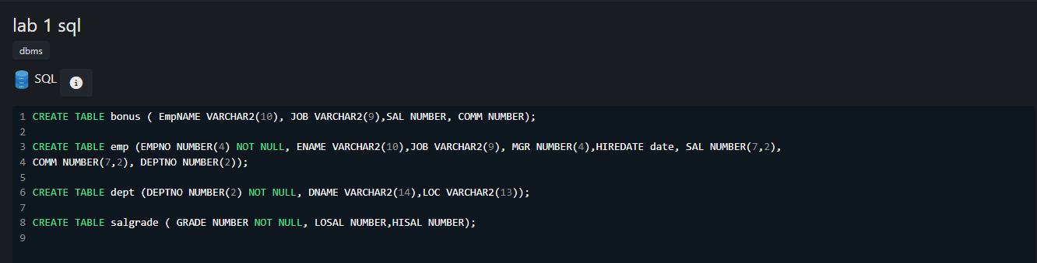

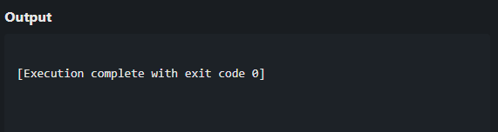

**Q2:** Insert the following data into tables:

1. emp table:

EMPNO ENAME JOB MGR HIREDATE SAL COMM DEPTNO

|  |  |  |  |  |  |
| --- | --- | --- | --- | --- | --- |
| 7369 SMITH | CLERK | 7902 17-DEC-1980 | 800 | 20 |  |
| 7499 ALLEN | SALESMAN | 7698 20-FEB-1981 | 1600 | 300 | 30 |
| 7521 WARD | SALESMAN | 7698 22-FEB-1981 | 1250 | 500 | 30 |
| 7566 JONES | MANAGER | 7839 02-APR-1981 | 2975 |  | 20 |
| 7654 MARTIN | SALESMAN | 7698 28-SEP-1981 | 1250 | 1400 | 30 |
| 7698 BLAKE | MANAGER | 7839 01-MAY-1981 | 2850 |  | 30 |
| 7782 CLARK | MANAGER | 7839 09-JUN-1981 | 2450 |  | 10 |
| 7788 SCOTT | ANALYST | 7566 19-APR-1987 | 3000 | 20 | |

7839 KING PRESIDENT 17-NOV-1981 5000 10

7844 TURNER SALESMAN 7698 08-SEP-1981 1500 0 30

7876 ADAMS CLERK 7788 23-MAY-1987 1100 20

7900 JAMES CLERK 7698 03-DEC-1981 950 30

7902 FORD ANALYST 7566 03-DEC-1981 3000 20

7934 MILLER CLERK 7782 23-JAN-1982 1300 10

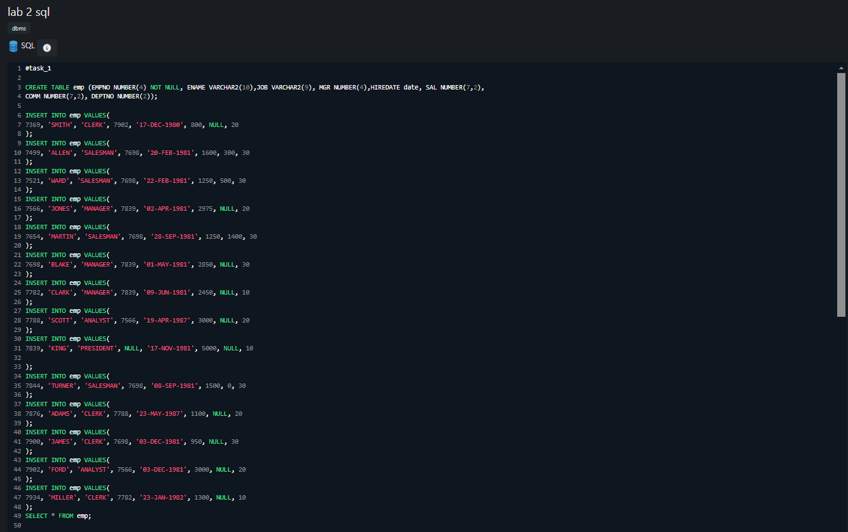

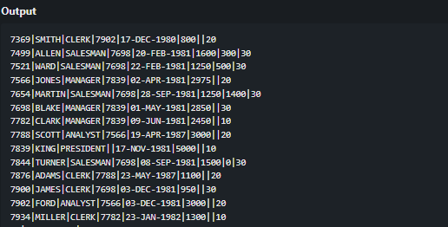

B )dept table:

DEPTNO DNAME LOC

10 ACCOUNTING NEW YORK

20 RESEARCH DALLAS

30 SALES CHICAGO

40 OPERATIONS BOSTON

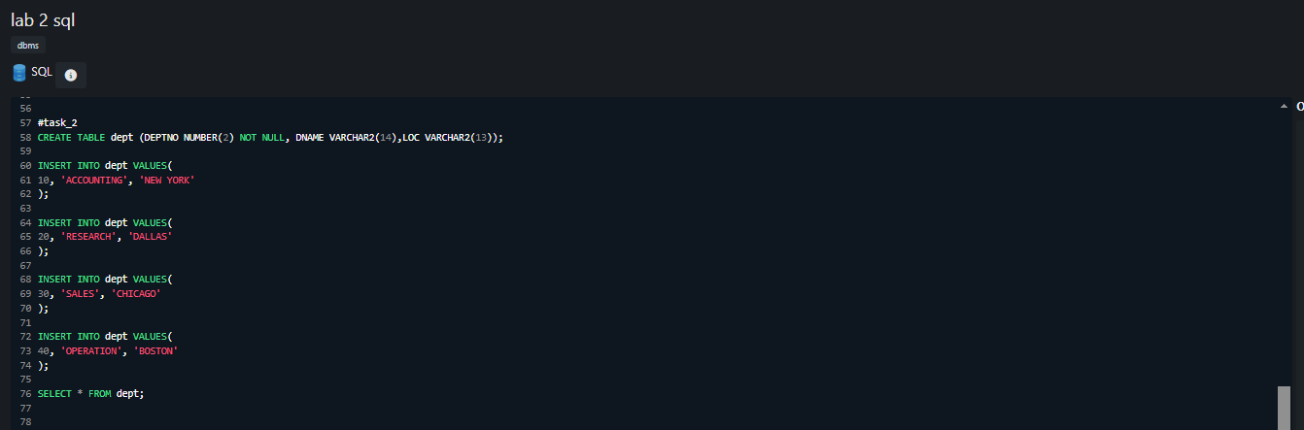

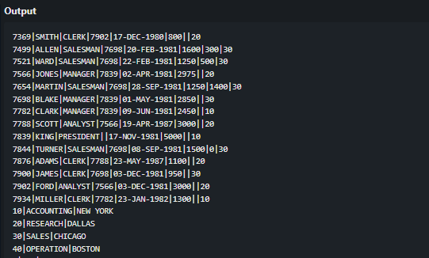

C)Salgrade

table: GRADE

LOSAL HISAL

1 700 1200

2 1201 1400

3 1401 2000

4 2001 3000

5 3001 9999

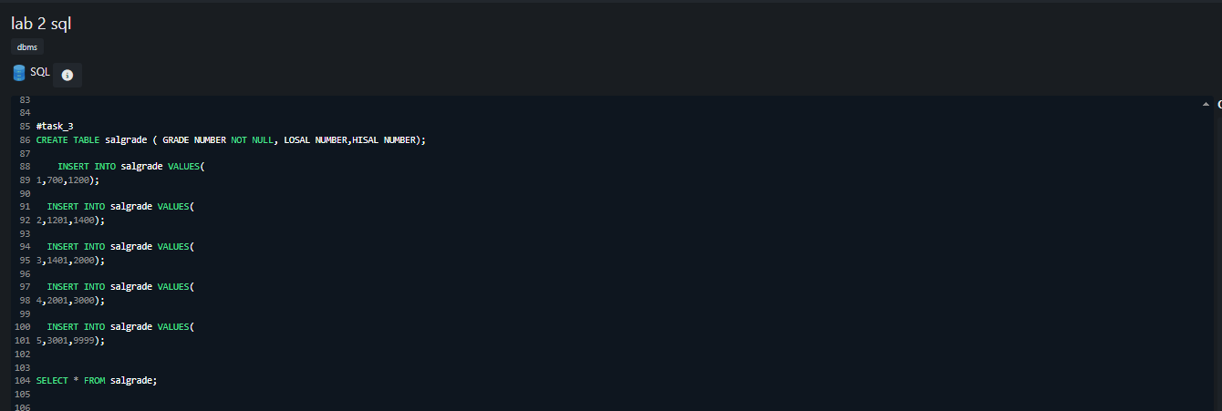

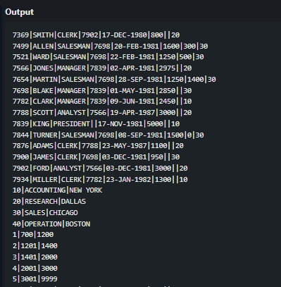

**Q3:** Create the following tables:

1. client_master

|  |  |  |
| --- | --- | --- |
| columnname | datatype | size |
| client_no | varchar2 | 6 |
| name | varchar2 | 20 |
| address1 | varchar2 | 30 |
| address2 | varchar2 | 30 |
| city | varchar2 | 15 |
| state | varchar2 | 15 |
| pincode | number | 6 |
| bal_due | number | 10,2 |

1. Product_master

Columnname datatype size Product_no varchar2 Description varchar2 Profit_percent number Unit_measure varchar2 Qty_on_hand number

Reoder_lvl number

Sell_price number

Cost_price number

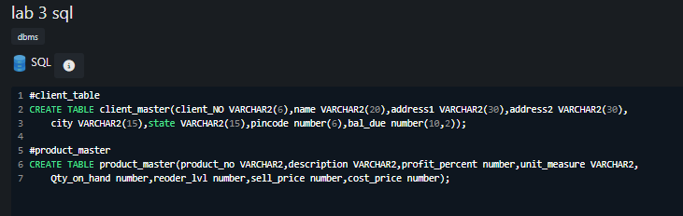

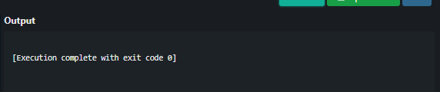**Q4:** Insert the following data

A)

Clientno Name city pincode state bal_due

0001 Ivan Bombay 400054 Maharashtra 15000

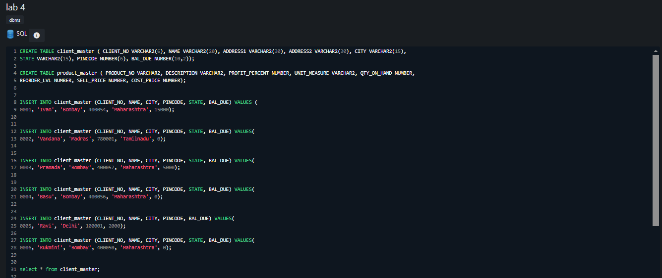

|  |  |  |  |
| --- | --- | --- | --- |
| 0002 | Vandana Madras | 780001 Tamilnadu | 0 |
| 0003 | Pramada Bombay | 400057 Maharashtra | 5000 |
| 0004 | Basu Bombay | 400056 Maharashtra | 0 |
| 0005 | Ravi Delhi 100001 | 2000 |  |
| 0006 | Rukmini Bombay | 400050 Maharashtra | 0 |

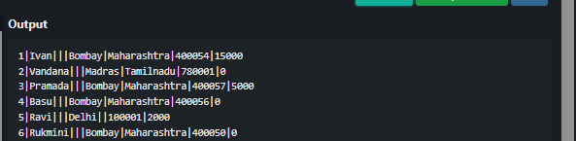

B)

Product No. Desciption Profit Unit Qty Reorder Sell Cost Percent measured on hand lvl price price

|  |  |  |  |  |  |  |  |
| --- | --- | --- | --- | --- | --- | --- | --- |
| P00001 1.44floppies | 5 | piece | 100 | 20 | 525 | 500 |  |
| P03453 Monitors | 6 | piece | 10 | 3 | 12000 | 11200 |
| P06734 Mouse | 5 | piece | 20 | 5 | 1050 | 500 |
| P07865 1.22 floppies | 5 | piece | 100 | 20 | 525 | 500 |
| P07868 Keyboards | 2 | piece | 10 | 3 | 3150 | 3050 |
| P07885 CD Drive | 2.5 | piece | 10 | 3 | 5250 | 5100 |
| P07965 540 HDD |  | 4 | piece | 10 | 3 | 8400 | 8000 |
| P07975 1.44 Drive | 5 | piece | 10 | 3 | 1050 | 1000 |  |
| P08865 1.22 Drive | 5 | piece | 2 | 3 | 1050 | 1000 |  |

